Creative Brief: Project Summary

In this project I will be creating a comic book website which is about toy story. I will use real life photos and manipulate them to make them have a comical look. The scene I have chosen to use is the Toy story opening scene, there is a range of movement and bubbly characters. Toy story is a movie sequel with star characters like woody a good-hearted cowboy who belongs to a young boy, the movie becomes interesting when the boy’s parents decide to buy him a Buzz Light-year toy action figure.

**Target audience:** With the exciting story line, it is clear to see that Toy story has a multi-gender audience. A typical age would be targeted towards primary school children, aged 4 years+ However, parents and teenagers would be also attracted to the film as the originals are nostalgic.

**Tone & Feel:**  I have chosen to follow a blue and white background, as I have a container in my prototype inside the container will have a deep sky blue background outside of the container will have white inline colour. I will be writing in Font Size 14 and the footer size will be 12 both of the font will be Calibri Light. I will incorporate images and videos, also social medias to make it look professional. I have chosen a font from the internet which has colour on it, for example the toy word has blue outline and for the story it has red outline of it. On the navigation bar I have chosen colour red as it blinds in with the colour of the background and the title.

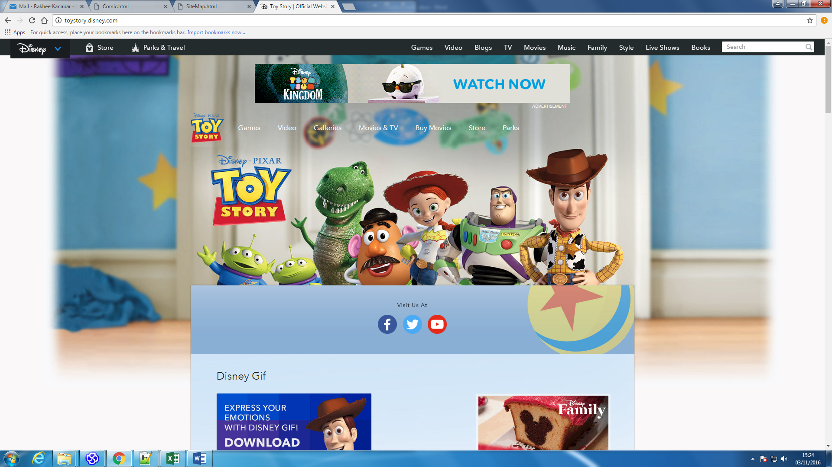

**I get my inspiration from the actual website. However, I changed the colour scheme as they have blue in the middle and white outside. I have white colour background for the inside and blue on the outside.**

**Colour Selection**: I have chosen this colour as it goes with the scene that I have chosen to adapt into a comic as well as tried to follow the actual Toy Story website feel.

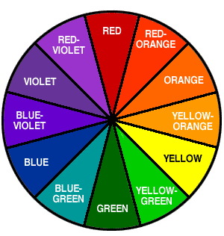

I will be writing in Font Size 12. Calibri Light, I will incorporate images and videos, also social medias to make it look professional.

**Navigation Models**:

The navigation I have chosen for the website is called full web navigation. The reason why I have chosen to follow this structure is because it allows users to navigate anywhere around the website, reducing the process of having to go back certain steps to reach their desired page. Full web navigation allows each page links to every other page as well as there being minimal risk of getting lost.